Micah Hoffmann

Assignment 06

7/30/2018

In this document, we will cover “managing state data” in .NET. The way data flows between the front-end and back-end of a website needs to be managed, .NET provides some useful tools so we can make sure data is stored in the correct place, and during the correct time period.

When the user logs in via the web site, to processes are triggered. A session object is created equal to the name entered in the form, and cookie is create based on the name column value for that user from the database.

The first step is to query the db and check if the name + email combo is valid, based on the RequestLogin entries in the system. If the Select is valid then we assign a session and cookie object.

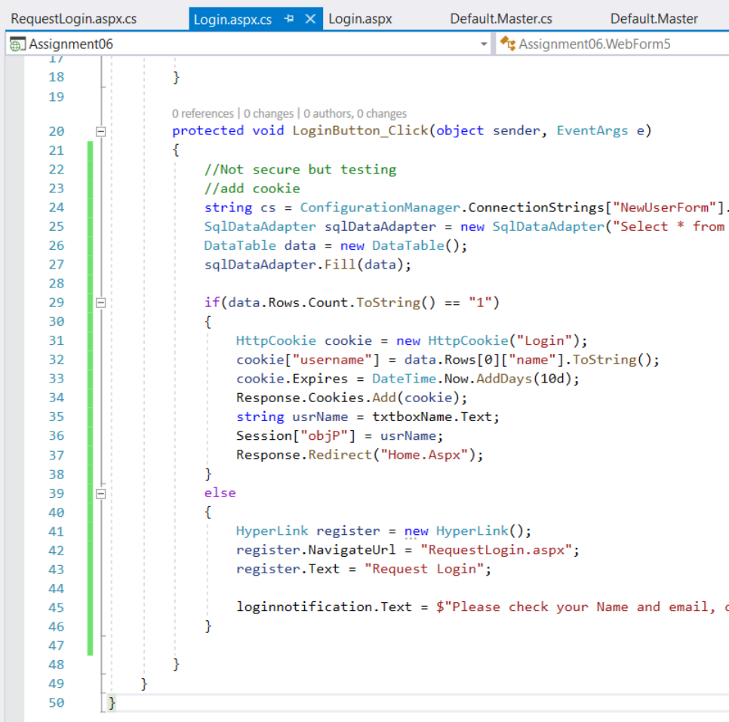

After the login, the user is redirect to the home page, which triggers the page_load of the master. On page_load we first check if the cookie is not null, if it is not null we check if the session is not null, if both equate to true, we append their name to the nav, add a logout button, and make the login button visible = false.

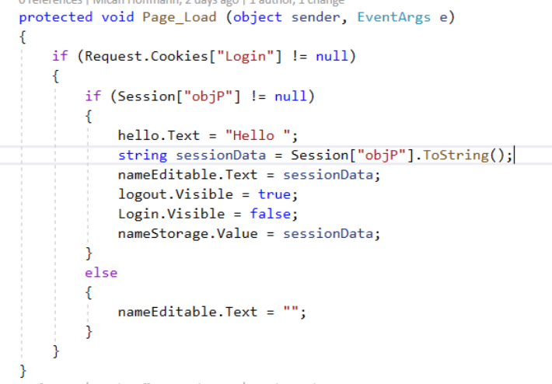

We will also use assign the value of a hidden field nameStorage = to the text passed in the session object. Then when the master header loads, we use javascript to assign the hidden field the value of the session text.

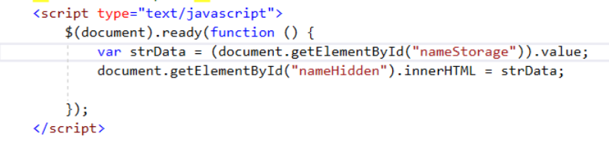

And finally we need to make sure the use can logout and clear their session

